Lab/Radiology - Integrated
PointClickCare has established a relationship with a lab clearinghouse, Liaison Healthcare Informatics to provide access to results from national, regional and local diagnostic testing providers that can be stored as a part of the medical record. After configuration, a facility has the ability to receive laboratory results electronically, both as structured data and PDF/images.

Viewing Integrated Results- Residents Chart

Procedure
Facility>Clinical>Resident Name>Results>Choose Laboratory or Radiology>view (next to results)
Displayed Data is sorted by Reported Date by default with the most recent data first. Sorting order may be reversed by clicking the arrow to the right of the Reported Date field.
To change the information shown, click the '+' next to Display Filters to set options for display.
When laboratory/radiology results are successfully transmitted to a facility, the results are automatically placed in the resident's medical record. When the view link next to the test is clicked, the results are displayed. In the top left corner of the pop-up, the laboratory and date are displayed indicating that the test was transmitted to the facility from the testing laboratory.
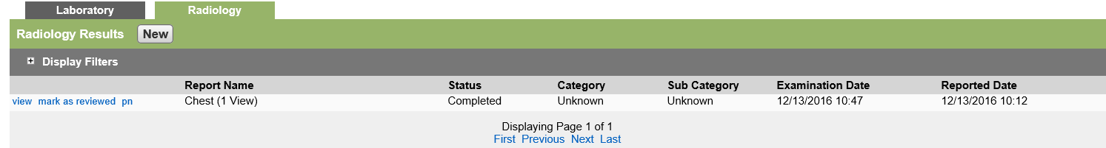
Abnormal results appear in orange, critical results appear in red.
Filter Options
- Click the + next to Display Filters to see results. After setting filters click Refresh to show selected data. Filter data by:

  - Reported Date - Filters lab reports by the Reported Date. The list contains the options:
  - On - shows results on a given date
  - Before - shows results up to a given date
  - After - shows results after a given date
  - Collection Date - Filters lab reports by the Collection date. The list contains the options:
  - On - shows results on a given date
  - Before - shows results up to a given date
  - After - shows results after a given date
  - Ordering Provider - Filters lab reports by the ordering provider. (Default - All Providers)
  - Report Status - Filters reports by Report Status: Completed, Resulted or Cancelled
  - Flags -Filters lab reports by Flag (abnormality). Normal, Abnormal or Critical
  - Category - Filters lab reports by Category: Chemistry, Hematology, Challenge, Semen Analysis, Cancer Screening Tests, Microbiology, Cytology, or Anatomic Pathology

Mark as Reviewed
After lab/radiology results are reviewed and the proper care path is followed, the results should be marked as reviewed to indicate completion of this task. Within displayed Results the following headings appear:
- Flag - Hovering over each of these icons reveals a message indicating the meaning of the icon.

  - Red Circle indicates a critical result
  - Yellow Triangle indicates an abnormal result
- Description - description of the test. For manual entry, the description appears as it is entered (free text). For integrated results, the description is populated by a pre-determined list of reports.
- Status:
  - Completed - No more results are expected for this report. All tests within the report are either Final or Invalid
  - Resulted - Report is still awaiting results and contains one or more tests with a status of Pending
  - Cancelled - All tests within the report have a status of invalid
- Category - category that the report belongs to. Multiple categories can be assigned to a single report.
- Collection Date - Date and time specimen was collected.
- Reported Date - Date the results were reported.
- Further manage the data by using the hyperlinks to the left of the description:

  - View
  - Mark as Read
  - Pn (Progress Note)

Procedure
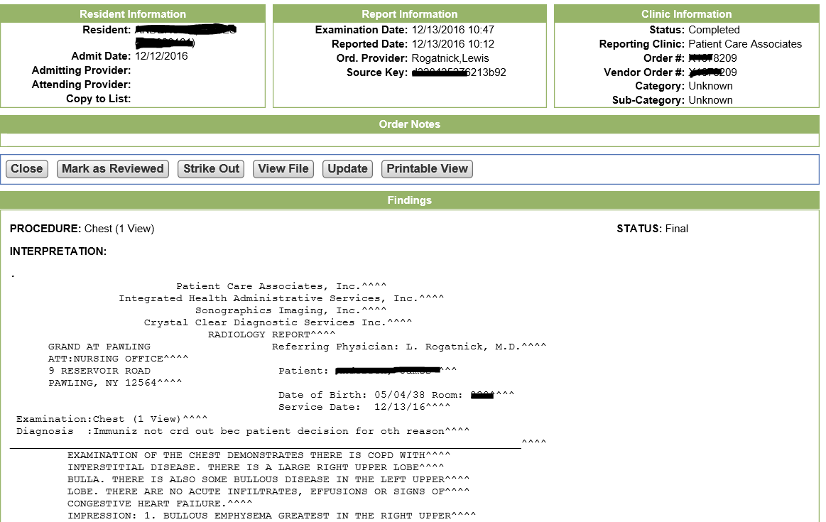
- Click the View link to the left of the selected lab.
After details of a report are viewed and appropriate clinical actions are taken, mark the report as reviewed to indicate no further action is necessary. Clicking the link mark as reviewed generates a pop-up asking if you want to mark the report as reviewed. Click ok to mark report as reviewed. The name and date of the user who marked the report as reviewed is recorded.
- When a report is marked as read, the mark as reviewed link is no longer available
- To return the results to unread, click the View link which opens the results of the test and click 'Mark as Unreviewed. The mark as reviewed link reappears next to the view link.

Clinical Dashboard
Un reviewed laboratory results entered into PointClickCare can be viewed and managed for all residents in the Clinical Dashboard, or for individual residents in the Resident Dashboard.
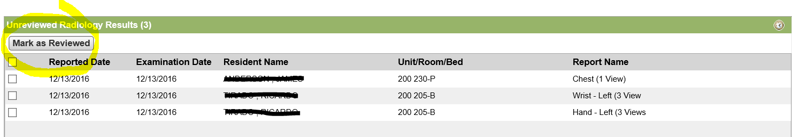

Procedure
- Open the Clinical Dashboard by clicking the Dashboard. In the Dashboard view the 'Unreviewed Laboratory Results' or “ Unreviewed Radiology Results” pane .
- Clicking on the Resident Name which is a hyperlink that navigates directly to the resident's Results page where unread results can be viewed and marked as reviewed.
- Alternately, if laboratory results are previously reviewed but not marked, this can be accomplished from the Clinical Dashboard.
- To mark a resident's laboratory results as reviewed, click the check boxed next to the appropriate laboratory test(s), then click the 'Mark as Reviewed' button at the top of the pane.

MANUAL ENTRY
INTEGRATED LAB AND RADIOLOGY RESULTS

Lab - Manual - New Entry - Step 1
- Facility>Clinical>Resident>Results.
- To manually enter new lab results into a resident's chart, click the 'New' button in the blue bar.
- Complete the information in each field in the 'New Report' section. Fields with red asterisks (*) are required fields.
- If a hard copy of the lab report is uploaded to the hard drive in your computer, access and attach that file by clicking the 'Browse' button (For Internet Explorer a 'Browse' button appears, in Google Chrome a 'Choose File' button appears. Information entered should match information on the hard copy of the original report.

Lab - Manual - Specimen Details - Step 2
Multiple tests can be run from the same specimen sample. Entering the specimen details saves the information as part of the test in the system.
- After entering the identifying information for manually entered laboratory results, move to the section 'Specimen Details' and complete the fields found there.
- Specimen Information entered is included in the test results. The 'edit' link to the right of the Specimen information allows the user to update the information if needed (i.e., if another test is being added that wasn't completed using that specimen).
When entering information the fields should be completed as follows:
- Specimen # - The number associated with the specimen collected
- Specimen Source - The type of specimen (Blood, Urine, Semen)
- Specimen Site Modifier - Where the specimen was taken from (i.e., Left antecubital)
- Collection Volume - The volume of specimen collected (i.e., 2ml)
- No of Sample Containers - The number of containers used for specimen collection

Lab - Manual - Recording Results - Step 3
Entering Results:
- In the Results section, click 'Add Detail' which enables a menu allowing selection of the type of report to be entered. Select from:
  - Add Panel
  - Add Test
  - Add Microbiology Results
  - Add Anatomic Pathology Results
  - Add Cytology Results
The appropriate fields for the test selected appears. Enter the test results as indicated for each field (copied from paper report).
  - If a Panel is being entered, select 'Panel', enter the name of the panel and the first set of results and then select 'Add Test' for each additional line (ie, Panel - Complete Blood Count, then Add Test - Eosinophils)
  - If you are entering multiple test results, click 'Add Detail' and select another test to be entered.
- If a Panel is being entered, select 'Panel', enter the name of the panel and the first set of results and then select 'Add Test' for each additional line (ie, Panel - Complete Blood Count, then Add Test - Eosinophils)
- If you are entering multiple test results, click 'Add Detail' and select another test to be entered.

Deleting Results:
- To delete an entry before it is saved, select the test to be deleted (click the line which highlights the entry)>click delete in the Results Blue Bar. A pop-up appears to confirm deletion. Click 'ok'. After a result is saved, it must be struck out. It can no longer be deleted.
Move Up/Move Down:
- To move a test up or down in the list of tests being entered, click the test that needs to be moved. The entry is highlighted. In the 'Results' Blue bar click the 'Move up' or 'Move Down' button to re-order the test results.
Save Results:
- After all entries are completed, click 'Save' to complete or 'Save and New' to begin another entry. A pop-up indicating that lab reports should be reviewed for accuracy appears, as well as any possible errors in entry which are flagged by the system.
- Click 'Cancel' to make any corrections (if needed), then click 'Save' again then 'Acknowledge' to save entries to the resident's chart. If no corrections need to be made, click 'Acknowledge'.
Content of the fields are as follows:
- Panel Name - The name of the panel or test. A panel is entered using free text and predictive search. A predictive search suggestion can be selected or free text can be entered.
- Test Name - The name of the test. A suggestion from the predictive search must be selected.
- Result - The test's result
- Units - The test's unit of measure
- Reference Range - The test's reference range
- Flag - A flag to indicate if the report contains any abnormal and/or critical results. The available flags are:
  - A - Abnormal non-numeric result
  - AA - Very abnormal non-numeric result
  - L - Below low normal
  - LL - Below lower panic limits
  - H - Above high normal
  - HH - Above high panic limits
  - <blank> - Result is normal (within range)
  - < - Below absolute low-off instrument scale
  - > - Above absolute high-off instrument scale
  - U - Significant change up
  - D - Significant change down
  - B - Better
  - W - Worse
  - I - Intermediate. Indicates for microbiology susceptibilities only
  - MS - Moderately susceptible. Indicates for microbiology susceptibilities only
  - R - Resistant. Indicates for microbiology susceptibilities only
  - S - Susceptible. Indicates for microbiology susceptibilities only
  - VS - Very susceptible. Indicates for microbiology susceptibilities only
- Status - The status of the test. Statuses available are:
  - Corrected - A correction to a Final results
  - Final - The result is verified and complete
  - Pending - Still awaiting the result
  - Invalid - The result is deleted or is no longer valid
    - Observation Method - The test's observation method
    - Nature of Abnormality - The test's nature of abnormality
    - Test Notes - Notes associated with the test

UN MATCHED LAB AND RADIOLOGY RESULTS - INTEGRATED

Lab - Integrated - Unmatched Laboratory Results
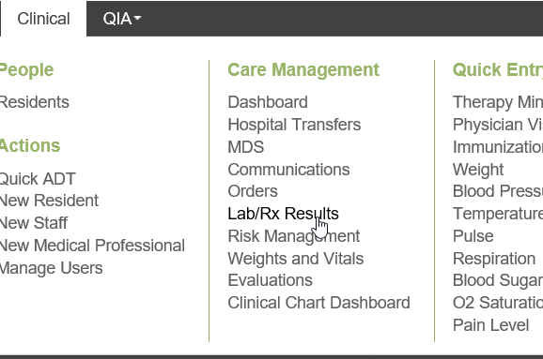
Sometimes when laboratory results are transmitted, there can be discrepancies in the record which prevent the match of inbound information from the laboratory with the correct resident in the facility (i.e., incorrect SSN on lab record). You can view and match these records to the appropriate resident's medical record. In addition, it is also possible that results are delivered which have no match in your database (wrong resident). In this instance, you can mark them as Unmatched in your database.

Procedure
- The unmatched laboratory results appear. The resulting view includes:
  - Resident name.
  - Date/Time Failed - indicating when the results were delivered but the match failed.
  - Number of Results in the report.
  - Type.
- Click match to the left of the resident name.
- A pop-up appears with the laboratory's resident information at the top and any potential resident matches listed below.
- To match the inbound laboratory result with the selected resident, select the radio button to the left of the resident name and then click the Same Resident button at the bottom of the screen. The laboratory report is moved to the resident's chart under the results tab.
  - Be careful when matching Unmatched Laboratory Results. After they are matched they cannot be Unmatched and must be struck out if incorrect but remains on the incorrect residents chart.
- If a lab result is delivered to the facility in error and no match can be found for the name, use the No Match Found button to remove the results from the list.

Hints & Tips
- As best practice the Lab/RX Results dashboard should be reviewed QShift.
- As best practice, the unmatched dashboard display filter, for the Failed Date, should be set to “Before” and “Today's Date”. This way you can see all the results that are on the unmatched dashboard.
- Items used for matching a result to a resident are:
  - Residents first name.
  - Residents last name.
  - Resident number (PCC number).
  - Date of birth.
  - Gender.
  - SSN (USA) /SIN (Canada).
  - Facility Name (in full).
  - Org Code.
  - Organization Name.
  - Confirmation Number.
- To review a list of unmatched records, select '+Display Filters' and check 'Show records resolved as "No Match" , then click Refresh.

Radiology - Integrated - Unmatched Radiology Results
Sometimes when radiology results are transmitted, there may be discrepancies in the record which prevent the match of inbound information from the radiology provider with the correct resident in the facility (i.e., incorrect SSN on radiology record). You can view and match them to the appropriate resident's medical record. In addition, it is also possible that results are delivered which have no match in your database (wrong resident). In this case, you can mark them as 'Unmatched' in your database.

Procedure
- Facility > Clinical > Care Management > Lab/RX Results.
- The unmatched radiology results appear. The resulting view includes:
  - Resident name.
  - Date/Time Failed - indicating when the results were delivered but the match failed.
  - Number of Results in the report.
  - Type.
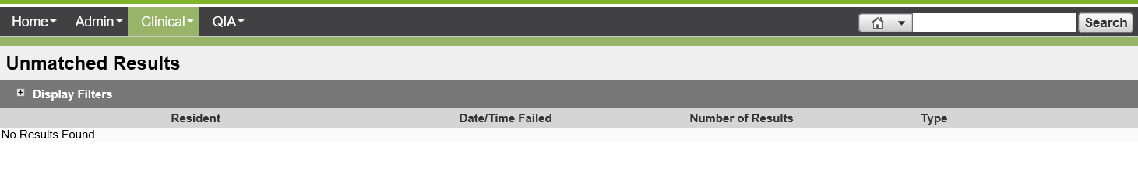
- Click match to the left of the resident name. A pop-up appears with the laboratory's resident information at the top and any potential resident matches listed below.
- To match the inbound radiology result with the selected resident, select the radio button to the left of the resident name and then click the Same Resident button at the bottom of the screen. The radiology report is moved to the resident's chart under the Results tab.
Be careful when matching Unmatched Radiology Results. After they are matched, they cannot be unmatched and must be struck out if incorrect but remain on the incorrect residents chart.
- If a radiology report is delivered to the facility in error and no match can be found for the name, click the No Match Found button to remove the results from the list.

Hints & Tips
- To review a list of unmatched records, select +Display Filters and check Show records resolved as "No Match" then click Refresh.
- Items to match a result to a resident are:
  - Resident’s first name.
  - Residents last name.
  - Resident number (PCC number).
  - Date of birth.
  - Gender.
  - SSN.
  - Facility Name (in full).
  - Org Code.
  - Organization Name.
  - Confirmation Number.

Reports

Lab Results Report
With this release, the Results module includes new reporting capabilities. A new Results section with Lab Results Report is available on the Clinical Report List page. This report provides a broad view of Lab results.
- From the Clinical reports select Lab Results Report.
- Set Display Filters.
- Run Report.
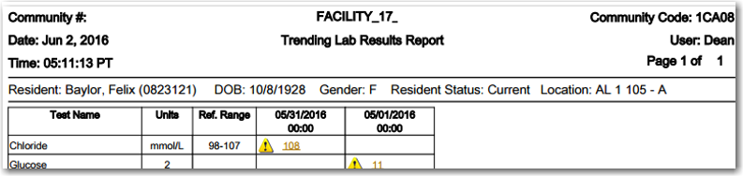
- When printing attachments the Unit/Floor must be selected. Only PDF and Doc/Docx attachments are printable.
- A signature line appears on the last page of each report.
- Abnormal results appear in orange font and critical results appear in red/bold font.
- Filter Options include: Ordering Provider, Reporting Lab, Category, Report Status, Flag, Reported Date Range, and Include Attachments.

Radiology Results Report
With this release, the Results module includes new reporting capabilities. A new Results section with Radiology Results Report is available on the Clinical Report List page. This report provides a broad view of Radiology results.
- From the the Clinical Report List select Radiology Results Report.
- Set Display Filters.
- Run Report.
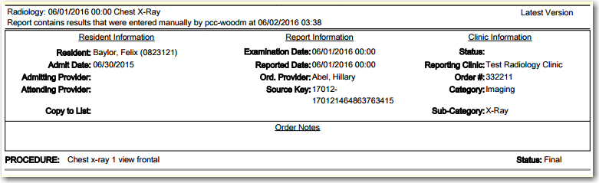
- When printing attachments the Unit/Floor must be selected. Only PDF and Doc/Docx attachments are printable.
- A signature line appears on the last page of each report.
- Abnormal results appear in orange font and critical results appear in red/bold font.
- Filter Options include: Ordering Provider, Reporting Radiology Clinic, Category, Sub-Category, Reported Date Range, and Include Attachments.

